**STILL IMAGE TAKEN FROM THE DOCUMENTARY UTOPIA BY JOHN PILGER**

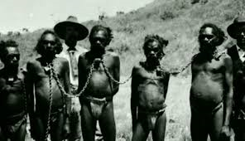

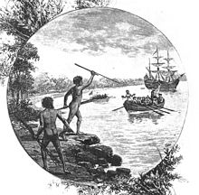

An engraving from "Australia: the first hundred years", by Andrew Garran, 1886 showing natives of [the Gweagal tribe](https://en.wikipedia.org/wiki/Gweagal) opposing the arrival of Lieutenant James Cook in 1770

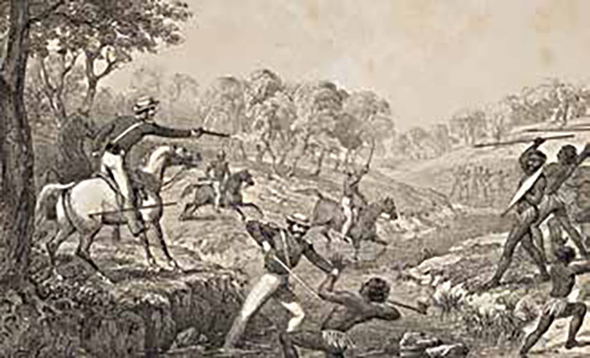

The Slaughterhouse Creek massacre in 1838. Mounted police responded to a conflict at Vinegar Hill on the Liverpool Plains north of central NSW. Sixty to 300 Aboriginal people were reported killed. Illustration: Godfrey Charles Mundy/Australian War Memorial

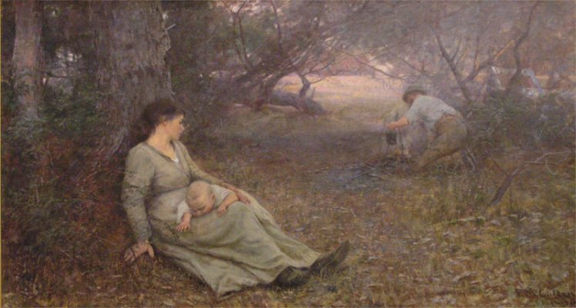

Frederick McCubbin: On the Wallaby Track 1896.